Azure Cloud Fundamentals and Data Pipeline Implementation using Azure Data Factory screenshots
Task 1:
Deliverable:Screenshot of Resource Group

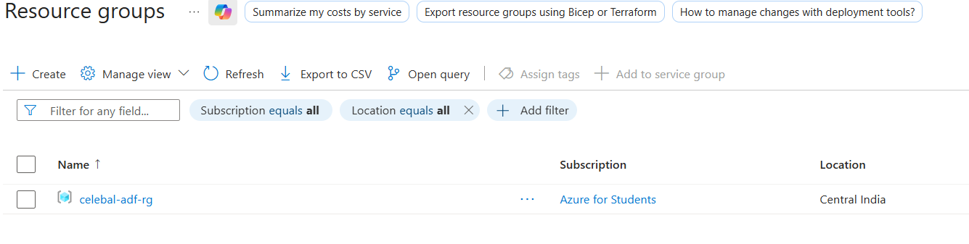

Task 2: Storage Setup
Deliverable: Screenshot of container with uploaded file

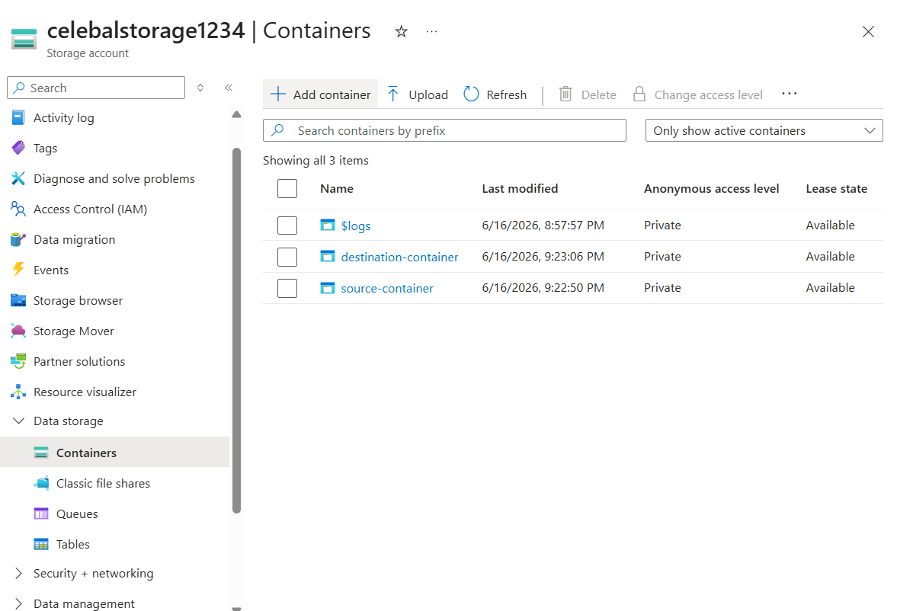

Task 3: ADF Basics
Deliverable:
- Screenshot of Linked Service
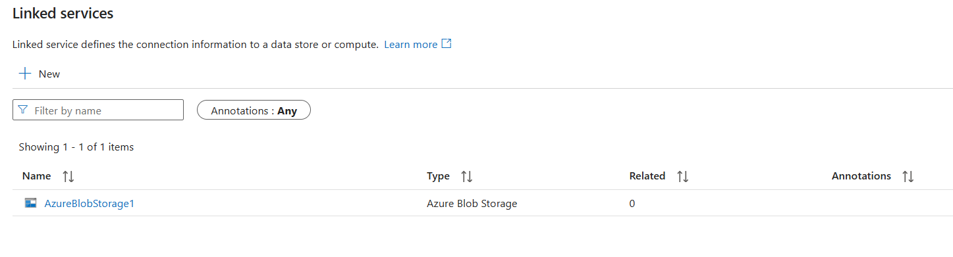

ii) Screenshot of dataset
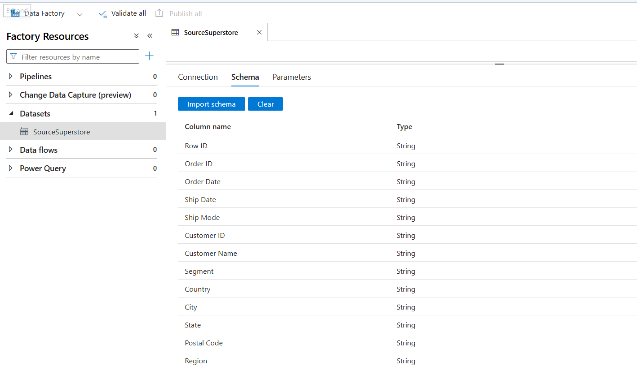

iii) Screenshot of Get Metadata activity
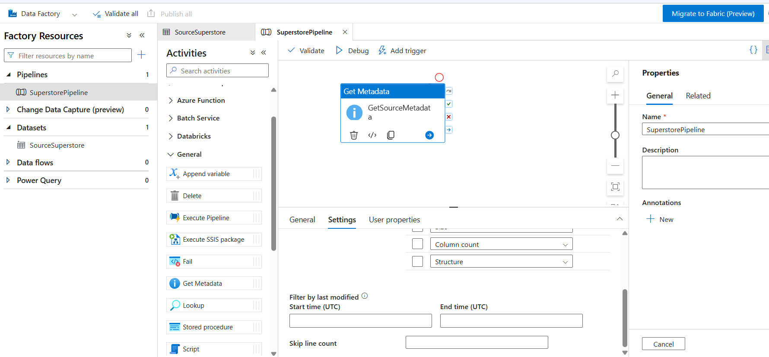

Task 4: Pipeline Development
Deliverable:
Screenshot of pipeline design
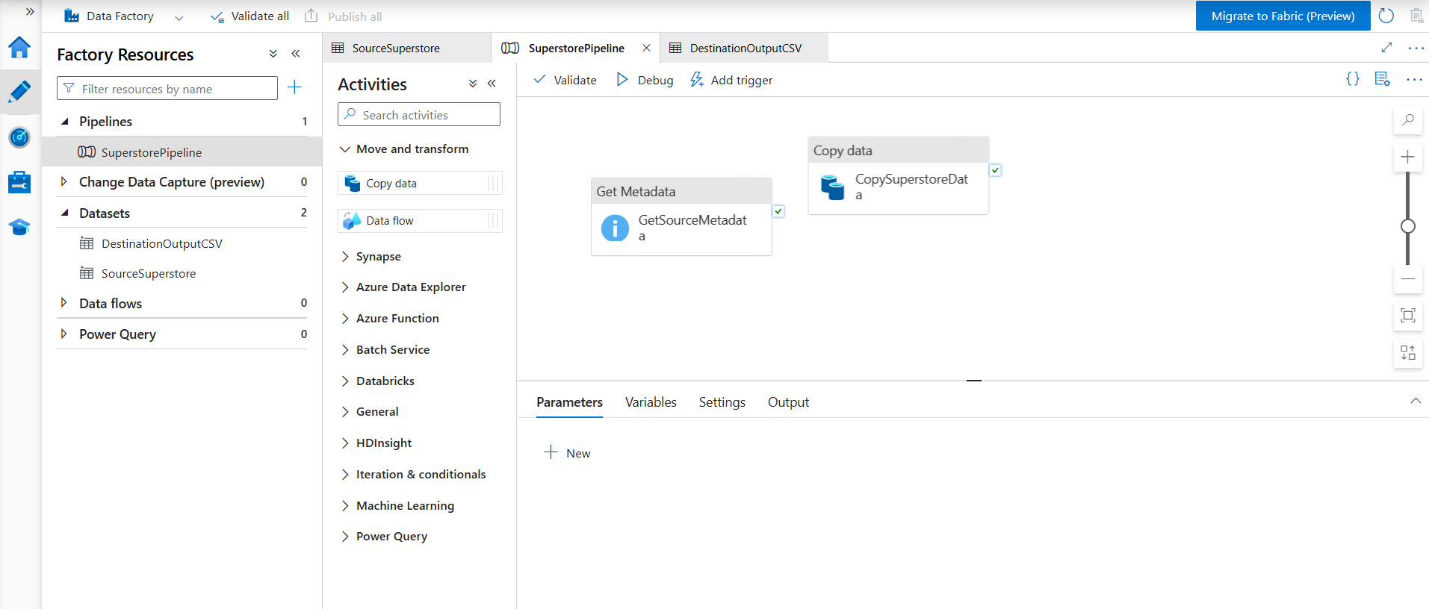

Task 5: Pipeline Execution
Deliverable:
Screenshot showing pipeline execution (Succeeded)

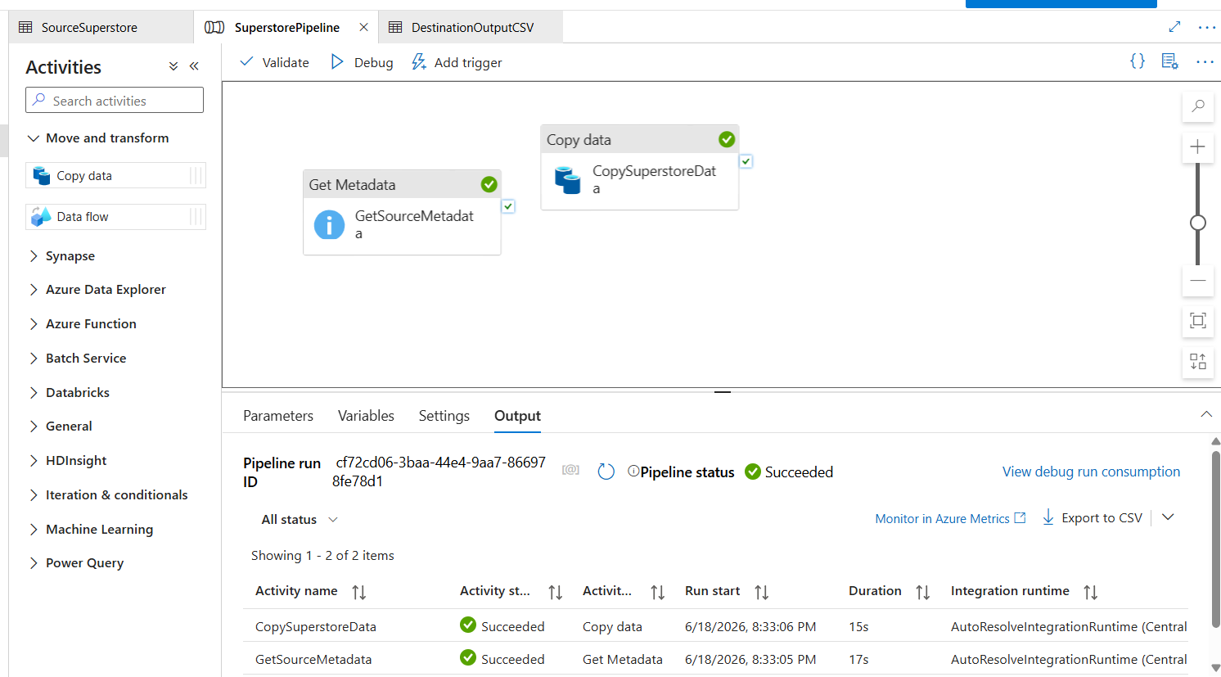

Verification of output:
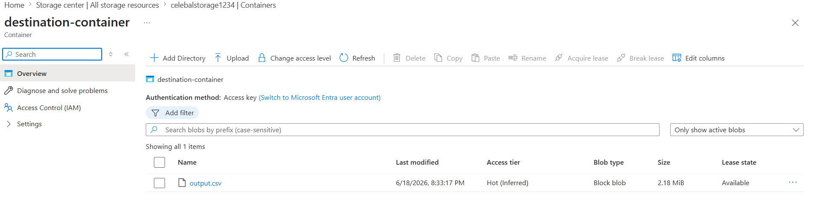

Task 6: IAM Roles
Deliverable:
Screenshot of role assignment

READER ROLE
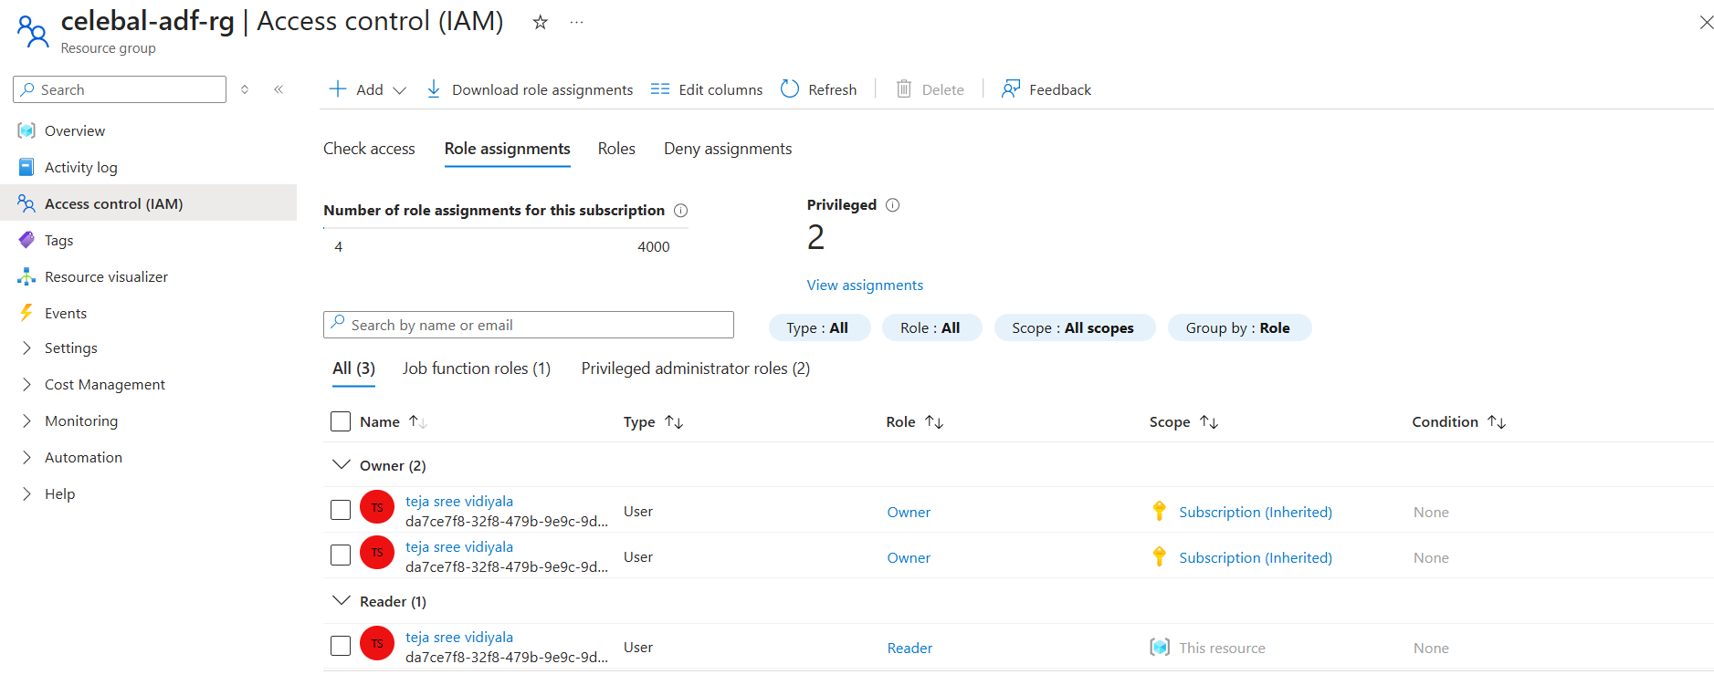

Contributor role was unavailable due to Azure subscription or permission limitations in the current environment.

Storage Blob Data Contributor Role
